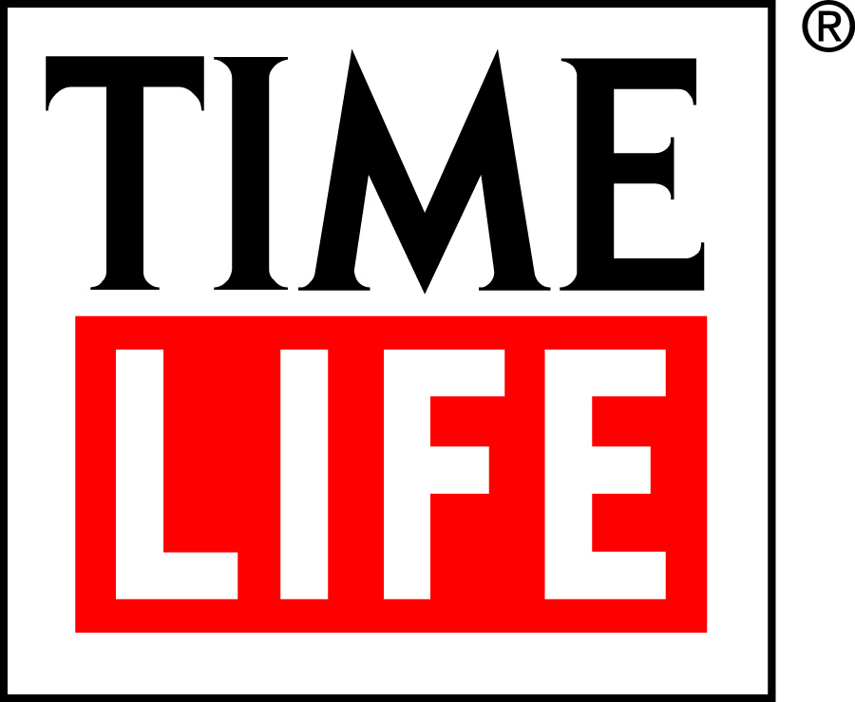

FOR IMMEDIATE RELEASE
April 30, 2020

TIME LIFE EXPANDS ITS RETAIL BUSINESS,
ANNOUNCES DIGITAL DISTRIBUTION DEAL WITH DON MCLEAN
FOR NEW, UNRELEASED AND RARE MUSIC
STARTING MAY 1

Fairfax, VA (April 30, 2020) –Time Life announces a new digital distribution partnership with Grammy®Award-winning artist and Songwriter Hall of Fame member Don McLean to bring new and previously unavailable music to the marketplace, using its significant internal sales and marketing resources along with an international distribution affiliation with Warner Music Group. As part of this new initiative, Time Life will be issuing 173 songs from 11 of his classic albums on May 1, marking the very first time they will be available on all digital platforms since their original release.
“Working with Time Life on this project has been the best thing that has happened to my recordings in years,” says McLean. “Everything I have ever done will be available on all the streaming platforms out there. Therefore, any song of mine you may have heard will be available. I hope people will have fun finding new songs.” Music from his albums Addicted To Black, Believers, Chain Lightning, Christmastime! The Complete Collection, For The Memories, Greatest Hits Live!, Prime Time, Rearview Mirror: An American Musical Journey, Don McLean Sings Marty Robbins, The Western Album and You’ve Got Songs To Share: Songs for Children will be released digitally and via streaming services on May 1.
“Don has an incredible body of work and our Time Life team is bringing all our considerable resources to making sure this repertoire is shared worldwide with Don’s existing and new fans,” says Mike Jason, Time Life Senior Vice President, Live Entertainment. Time Life will provide worldwide distribution, promotion and sales support, extensively redevelop and promote McLean’s YouTube channel with exciting new content and will work closely with his team to implement a sustained online and terrestrial publicity and promotional campaign.

Time Life offers artists and brands unparalleled opportunities to connect with their fans. As a longtime leader in multi-platform marketing, the company uses direct-to-consumer channels that reach nearly 90 million people each year. It also offers cross-pollination with its other divisions, including its award-winning direct response television division, a robust retail label, its StarVista LIVE experiential music-themed cruises and an extensive array of broadcast alliances.

About Don McLean:
Don McLean is a Grammy award honoree, a Songwriter Hall of Fame member, a BBC Lifetime Achievement award recipient, and his smash hit “American Pie” resides in the Library of Congress National Recording Registry and was named by the Recording Industry of America (RIAA) a top 5 song of the 20th Century. A New York native, Don McLean is one of the most revered and respected songwriters in American history. After paying his dues in the New York club scene in the late ‘60s, he went on to score mega-hits like “Vincent (Starry, Starry Night),” “Castles in the Air” and many more. His catalog of songs have been recorded by Madonna, Garth Brooks, Josh Groban, Drake, Weird “Al” Yankovic, and countless others. In 2015, one of McLean’s four handwritten manuscripts of the lyrics to “American Pie” was auctioned by Christies, selling for just over $1.2 Million. 2019 honored Don with a star on the Las Vegas Walkway of Stars and his song “And I Love You So” was the theme for Prince Harry and Meghan Markle’s wedding. Now in 2020, Don signed a recording contract with Time Life to release his catalog of recordings as well as the much anticipated new album Still Playin' Favorites, which will be released in the Fall. “American Pie” will be featured in the Avengers Black Widow and the Tom Hanks movie BIOS and much more to be announced. And when you think things are slowing down, not so for Don McLean! 2021 will mark the 50th anniversary of American Pie with a World Tour to follow.

About Time Life

Time Life is one of the world’s pre-eminent creators and direct marketers of unique music and video/DVD products, specializing in distinctive multi-media collections that evoke memories of yesterday, capture the spirit of today, and can be enjoyed for a lifetime. TIME LIFE and the TIME LIFE logo are registered trademarks of Time Warner Inc. and affiliated companies used under license by Direct Holdings Americas Inc., which is not affiliated with Time Warner Inc. or Time Inc.

# # #

Suggested Tweet:
.@DonMcLeanOnline releases 173 classic songs online, making them all available on digital platforms for the first time ever via @TimeLifeUS.

